LAB REPORT

NAME : CHIRAG GUPTA
ROLL NO. : 2501940006
COURSE : DEEP LEARNING ARCHITECTURE & TECHNIQUES
COUSE ID : ETMMDL274
ASSIGNMENT TYPE : PRACTICAL LAB
DATASET USED : Loan_Default.csv
TOOLS : Python, GoogleColab, PyTorcch ,Scikit-learn ,Matplotlib , Pandas

- Dataset Description :
So, in this experiment we will use the dataset Loan_Default. csv file holding information related to the loan applicants credit. It contains 34 input features: applicant demographics, financial attributes, and credit history related identifiers; loan-related features including amount, purpose, term etc.; application details. The aim is to make a binary classification and as such predict if an applicate belongs under Status = 0 or Status = 1 (target variable).

Key Columns :
- Gender – Gender type of applicant
- Age Group – Ranges such as 25-34, 35-44
- Credit_Worthiness – Indicates L1/L2 rating
- Credit Score – Integer credit score
- Open Credit – Type of open credit
- Loan Purpose – Purpose of taking loan(p1,p2,p3….)
- Region – Applicant region
- Security Type – direct/indirect
- LTV – Loan-to-value ratio
- Status(Target Variable) – 0 or 1

The dataset contains categorical and numerical variables. As several fields (type1, p1, l1 etc) represent categories universe encoded to integers beforehand thus requires processing prior training of models.

- Data Preprocessing
For the preparation of the dataset for the MLP model, the following steps were taken :

- Handling Target Variables
The target variable column “Status” is converted into integer values of either 0 or 1 and cleaned for any inconsistencies:
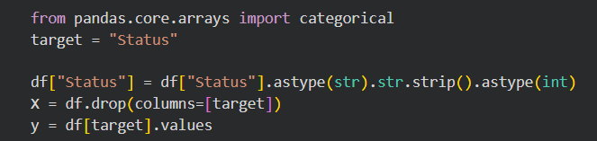

- Splitting Dataset
Features (X) and labels (y) were separated:
- X : All columns except Status
- Y : Status column

- Encoding Categorical Variables
As the dataset contains a lot of categorical variables such as gender, region, loan_type, etc , On-Hot Encoding is used for this purpose .
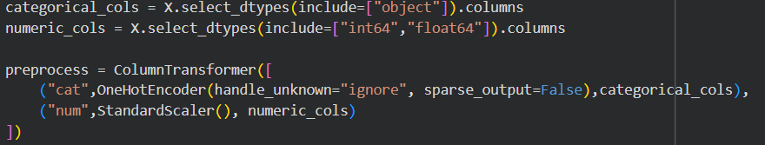

- Scaling Numerical Features
Numeric columns were normalized using the StandardScaler to ensure uniform magnitude in the columns, which is helpful in stabilizing the training process of the neural network.

- Handling Missing Values and NaN
After transformation, any NaN values were replaced using:

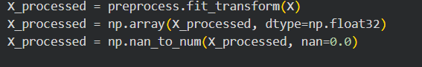

- Train-Test Split
The processed data is split into:
- 80% for training
- 20% for testing
This is done in order to evaluate the model’s performance.

- MLP Architecture
A Multi-Layer Perceptron neural network is created using PyTorch. The neural network architecture is as follows:

Input Layer
- Number of Input Nodes = Number of encoded features after preprocessing
- Input is passed through fully connected linear layer

Hidden Layers
- Hidden Layer 1
- 64 neurons
- Activation Function = ReLU
- Hidden Layer 2
- 32 neurons
- Activation Function = ReLU

Output Layer
- 1 neuron
- Activation Function = Sigmoid
- Output is between 0 and 1 (probability of Status = 1)

Loss Function
- Binary Cross Entropy Loss (BCELoss)

Optimizer
- Adam Optimizer
- Learning rate = 0.001
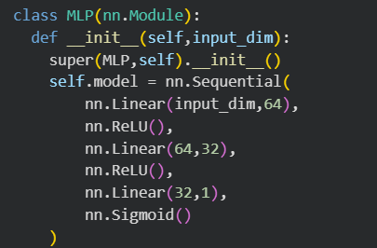

4. Training Curves
The model was trained on 30 epochs, with a batch size of 32.
Training Loss Curve
If there’s a decreasing trend in the curve, it means the model learned the patterns from the data.
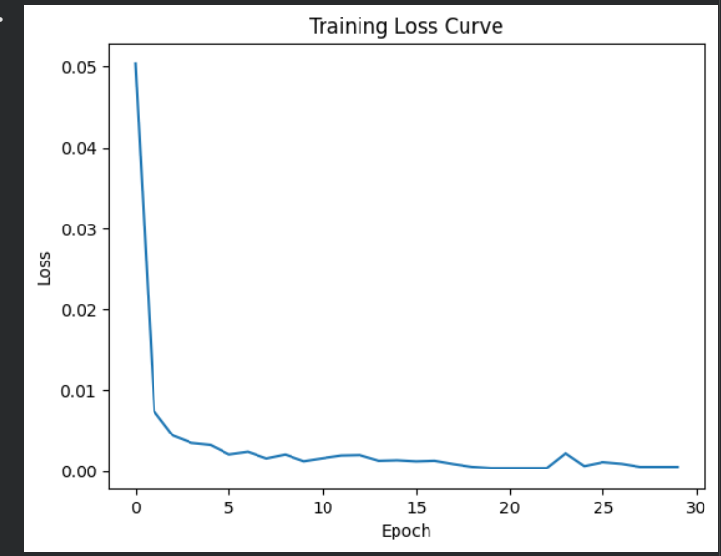
- Model Evaluation Metrics
The model was then tested using the unseen data provided for the test.
Predicted Values

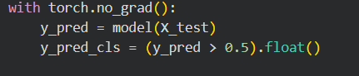

Evaluation Metrics

Metric | Value
Accuracy | 0.9998654738682989
Precision | 0.9998618402873722
Recall | 0.999585635359116
F1 Score | 0.9997237187456831

Confusion Matrix
[[22493 1]
[ 3 7237]]

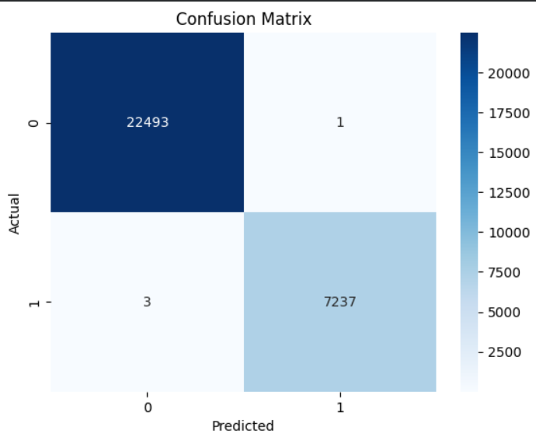

- Discussion
The MLP classifier was able to learn meaningful patterns from the credit data set. The loss curve shows that the loss is decreasing, indicating that the model has learned properly. The accuracy, precision, recall, and F1 score metrics give an idea about the performance of the neural network in distinguishing between the two classes, i.e., Status 0 and 1. The confusion matrix gives more information about the true and false values, helping us understand if the model is biased towards any class.

The performance of the model is quite good, but it can be further enhanced by adjusting the hyperparameters, increasing the number of hidden layers, and changing the learning rates as well as the optimizers. Domain-specific preprocessing may also be helpful for better results. The model can also be replaced with other machine learning models such as Random Forest Classifier or Gradient Boosting Classifier. Deep neural networks can also be used such as dropout for regularization.

